Anthony Arnopoulos
Clouds report 1
MCEN 4151
10/24/2021

It’s so Fluffy

Introduction
For our third assignment of the year, our teacher decided to give us the opportunity to depict one of the most undervalued things in the world; clouds. For the last few months I have been keeping my eye out for one of the most interesting clouds that I could see. I finally got some clouds that captured my attention. The reasoning behind how it caught my attention you may ask? Is the reasoning behind this assignment. The purpose behind this assignment is to appreciate the natural paintings that surround us and to grasp a better understanding of the phenomena behind them.

Picture Details
For my image, I took this photo in one of the most beautiful places in the world; Boulder, Colorado. At approximately 3:59 on September 13th, 2021, I happened to look up into the big blue sky, pulled out my phone camera, aimed it at a 80 degree angle (from the ground) to the sky and snapped the photo. I personally thought this was a good photo purely because it showed a lot of vibrant colors, depth, and contrast.

Indepth Analysis
From this photo and its skew-t diagram, we can pick some details out that would help us better understand the clouds. The few things that we can look at is the type of clouds/weather patterns and the skew-t diagram of this particular day.
To start us off, I would like to talk about the actual types of clouds in the picture. I identified statocumulus, cumulus and stratus clouds. I identified the types of clouds by referring to the following image (via. sciencefacts.net).

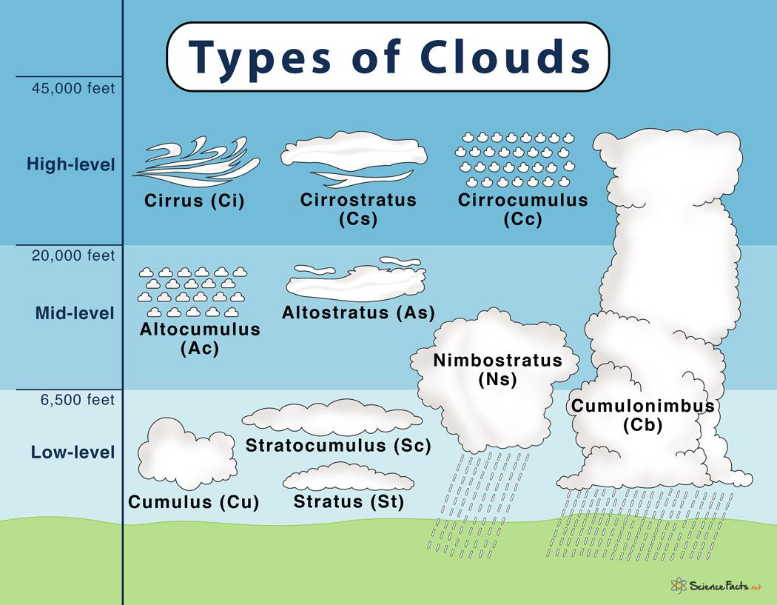

I came to this conclusion by referencing my memory, the picture and the picture above. During this day, I remember the clouds veins very close to the ground. I then looked at the detail in the clouds and compared them to what the cumulus, stratocumulus, and stratus cloud look like. After careful consideration and detailed analysis I came to my final conclusion. It was also convincing to me that these were the right kinds of clouds due to the fact of weather. Looking back on the prior days and the day of, there were no signs of raining or any type of moisture build up. This means that by the human eye the clouds seemed to be stable.
Which leads me to my final point; how can we tell if it is going to rain and our atmosphere is unstable? We can easily come to this conclusion by referring to the skew-t diagram (provided to us by the University of Wyoming). Using the following skew-t graph from a near by station in Denver, Colorado, we can come to the conclusion about the atmosphere and its stability.

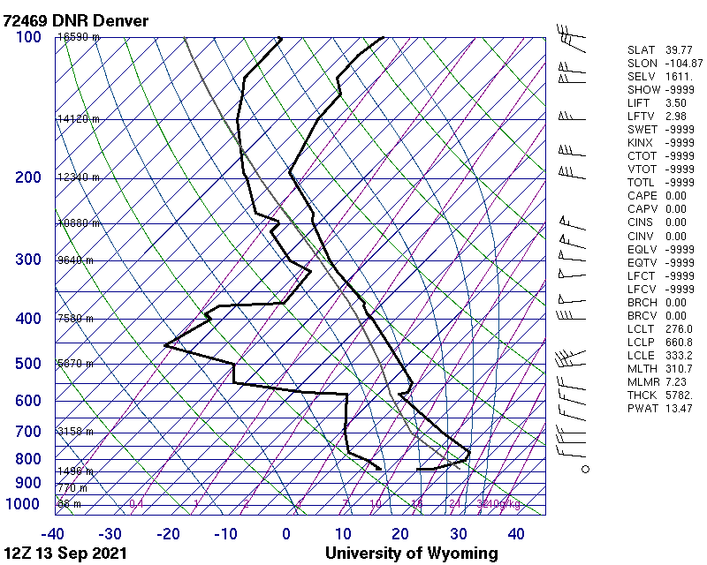
The CAPE value or the convective available potential energy is all we need to know to determine if the atmosphere is stable or unstable. If our CAPE value is anything other than zero, our atmosphere is unstable. This is because there is enough potential energy to create an updraft in storms that allow for rain and condensation to form. Looking back at our values on our skew-t graph, we can see that the CAPE value is zero. This means that our atmosphere is stable and there is no potential energy in our atmosphere.

Photographic Tecniques
As for the camera details and setup, I decided to go with an iPhone 11 pro camera and took the photo in the portrait orientation. For the settings of the camera, the iPhone has limited variability so I used the default settings of the phone (settings of which are not very clear). This photo was taken with the iPhone 11’s 12 MP telephoto camera with a ƒ/2.0 aperture.
As for the post processing, I used the iPhone’s editing tools to bring out more color and depth in the photo. The settings that I decided to change in the photo can be seen below:

Setting: | Value:
Exposure | -39
Brilliance  Highlights | 53  -39
Contrast | 7

By using these post processing values, I was able to change the photo as depicted below:

Original | Post processed
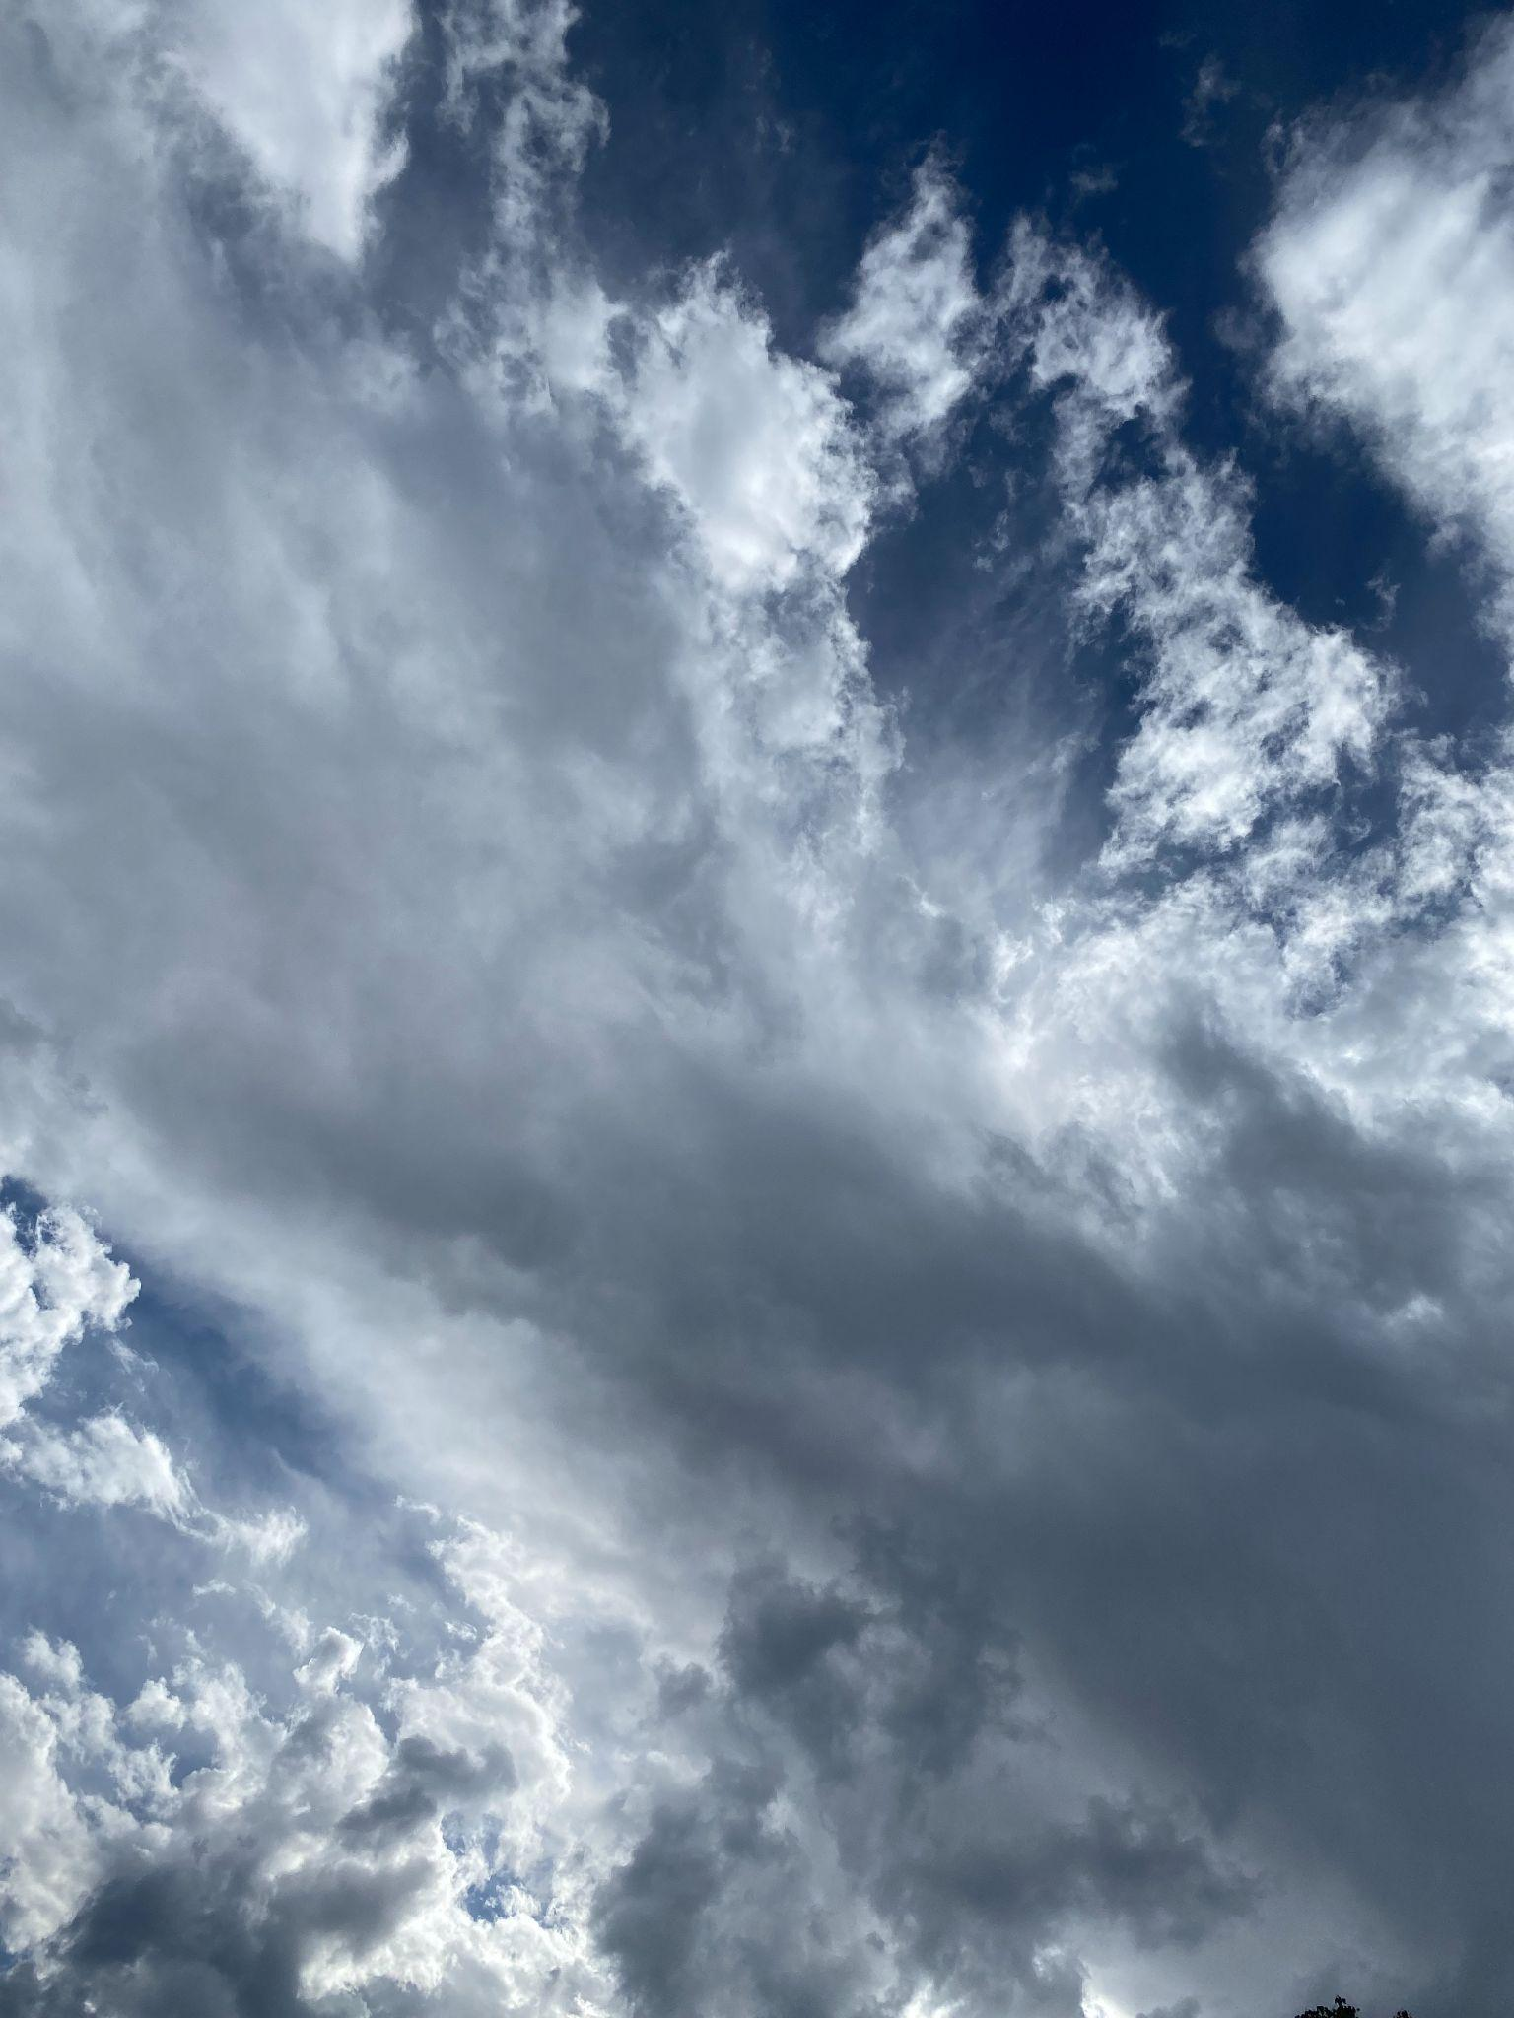 | 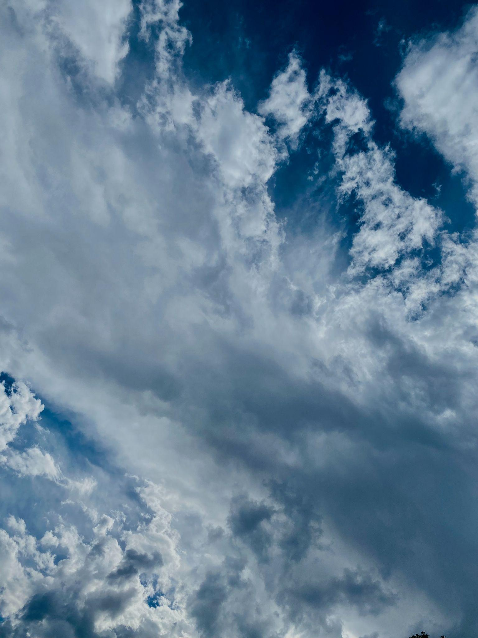

By closely looking at the images, we can see just how small but drastic the post processing did for my photo.

Conclusion:
In conclusion I think I was perfectly able to capture the true beauty of the world’s natural art. Though I may have had the most expensive equipment for the job I think I was able to show the world how beautiful clouds can really be. The vibrant colors, the textures, the depth, and the clouds themself all come together to create a masterpiece.
If I was to change anything about what I did for this photo would be to perhaps take the photo with a higher grade camera. I think the iPhone’s camera was able to capture the beauty for this assignment’s intent but I still think it could be better with different focal lengths, exposures, size of views.
Overall, I think I was able to capture my intent and share it with the world. Though the camera that I used may not be the best, I personally believe that no matter what camera you use, you cannot fully capture the true beauty of the world without

References
- “Types of Clouds: Their Formation & Meaning Explained with Diagram.” Science Facts, 18 Nov. 2020, https://www.sciencefacts.net/types-of-clouds.html.
- Atmospheric Soundings, http://weather.uwyo.edu/upperair/sounding.html.
- “Types of Clouds: Their Formation & Meaning Explained with Diagram.” Science Facts, 18 Nov. 2020, https://www.sciencefacts.net/types-of-clouds.html.

